Lab 11: Breaking Protections

CYBR 688: Software Reverse Engineering

Team Members: Sairam Bokka, Ethan Hart

Introduction:
This lab aims to break the protections on a provided key generator file that employs anti-reversing techniques. By breaking the protections on this key generator, we aim to observe the sensitive key generation algorithm in this file and rewrite the algorithm into the source code of a new key generator file that can verify and reject the same usernames and keys as the original executable.

Materials:
-Licensed copy of Linux (Ubuntu 24.04.1 Virtual Machine used for this lab).
-Supplied lab files from Blackboard, which includes the hardenedcrackme executable file and a ReadMe file containing a valid username and key pair.
-A copy of the latest version of Ghidra for static and dynamic reverse engineering,

Procedure
- First, verifying that hardenedcrackme works as intended is good practice. To test this, we run the executable with the provided username and keys.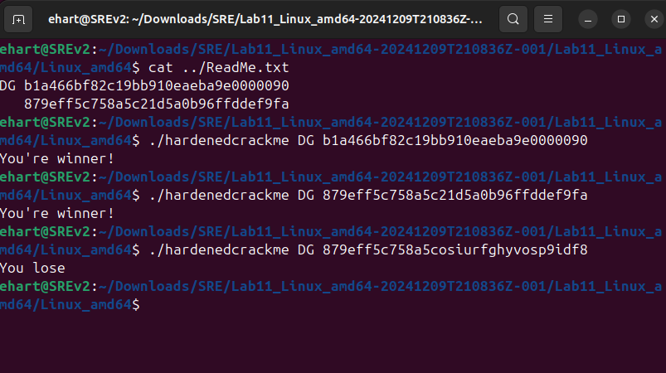
Testing the usage of hardenedcrackme.

- When attempting to run this executable in gdb to discern the algorithm that generates keys, we run into the following error:
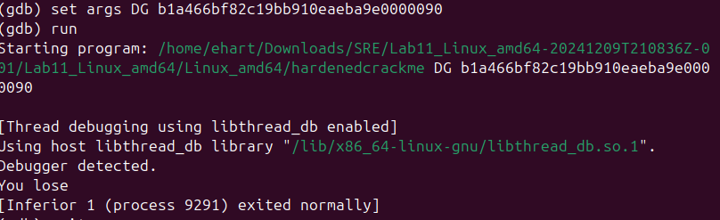
Debugging error found when attempting to debug hardenedcrackme with gdb.

- Hardenedcrackme is using an anti-reversing method to prevent a reverser from performing dynamic analysis. The next section will cover how this method is defeated.

Disabling Dynamic Analysis Protections
- To find where hardenedcrackme is disabling user debugging, we open up Ghidra, create a new project, import hardenedcrackme, and analyze the file. Once the file is analyzed, we navigate to the symbol tree to see what kinds of imported and exported functions exist. One import that draws attention is the function ptrace().
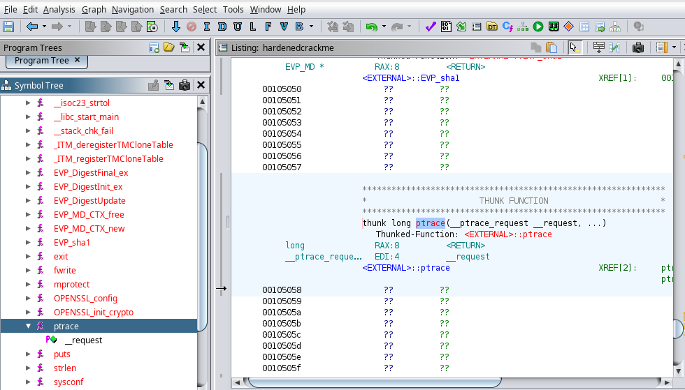
The inclusion of the system call ptrace() as an import in hardenedcrackme.

- Ptrace() is a Unix system call that is used when one process wants to take control of another process. One caveat of this call is that a process can only be controlled by a single process at a time. If a process attempts to take control of a process that already has a tracer, the function will return -1. Thus, it is possible for a programmer to embed a ptrace() call into their code to check if their program is currently being traced by another process such as a debugger.
- We can follow the references to ptrace() in the disassembly to reach a function that calls ptrace(), checks if the return value is -1, and halts if the process has a tracer. To disable hardenedcrackme’s usage of the ptrace(), we employ a novel patch that changes the jump condition to an arbitrary value 0x11 which will never be returned by ptrace().
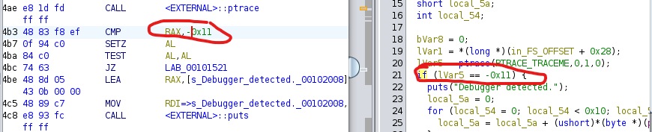
Patch applied to hardenedcrackme to disable the debugging halt.
- The patched executable is then exported as “hardenedcrackme_debug_patched” and now successfully runs when imported into the gdb debugger.
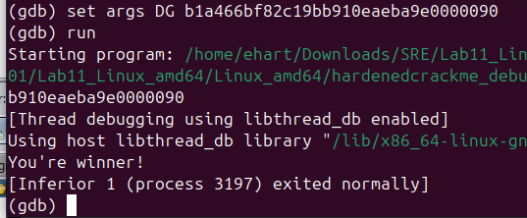
Gdb running successfully with the patched version of hardenedcrackme.

Defeating Static Analysis Protections
- To start, we open our newly patched version of hardenedcrackme in Ghidra. Upon analysis, Ghidra can take us to the entry point of the program. The entry point of the program points to a function titled “FUN_0010177a”.
- By following this reference, we arrive at the implementation of this function, which seems to be a main function as it prints out an error if a username and key aren’t provided, calls a function titled “FUN_00101349”, and returns either “You lose” or “You’re a winner!” based on the return value of the function.
- By now, it is obvious that one static analysis protection employed in this executable is the stripping of symbolic information. To make sense of this crackme, we will have to carefully rename and retype variables and functions as we go.
- To start, we will rename the function’s first parameter to “argc” as it represents how many arguments have been passed. We will also retype and rename the second parameter to “char* argbuff”, as offsets of this parameter (most likely username and key) are sent as parameters to FUN_00101349.
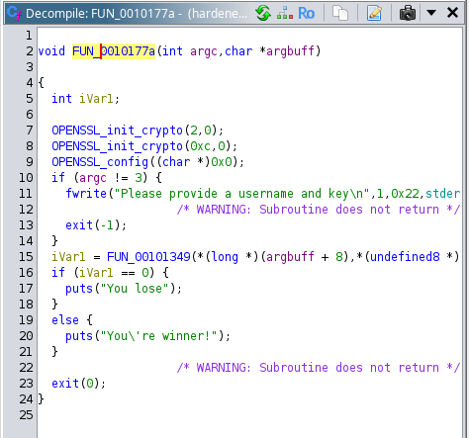
Entry point function in hardenedcrackme.
- Following the call to FUN_00101349 and performing a brief analysis of the function reveals a few things:
  - The function uses the call strtolen() on the second function parameter. This affirms the previous suspicion that this parameter is the provided key held in the argument buffer in the main function. By process of elimination, this also affirms that the first function parameter here is the provided username.
  - If the key is 32 characters long, the key is copied into a temporary buffer and stored as a long.
  - The username and key are passed to a function titled “FUN_00101472”, and the result of that function is returned to the main function.
- Since FUN_00101349 is just converting the key and calling another function, we change the title of FUN_00101349 to be called “doCheckConvert().
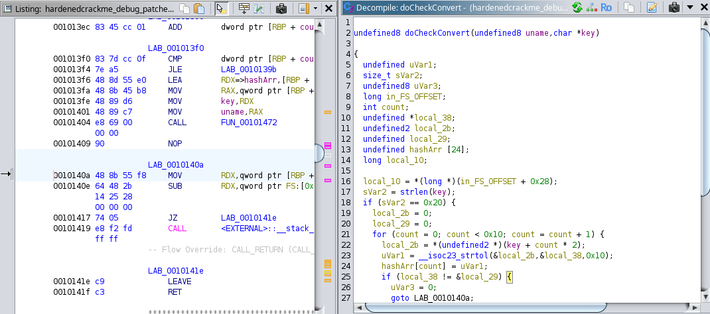
Function renamed to doCheckConvert().
- We then follow the reference to FUN_00101472 and analyze the function. Note that this is the same function detailed earlier that executes a call to ptrace(). Since we now know the call stack of this executable up to this point, the existence of ptrace() in this function, as well as a call to mprotect(), suggests that this function may be housing the sensitive information we are looking for.
- In this function, we can note the following:
  - Following the patched ptrace() code block that is now unreachable, a memory address is computed and passed into mprotect() with protections on reading, writing, and executing.
  - A for-loop that goes from memory address 0x101598 to 0x101730, and XOR’s the value at each memory address with 0xcc. This is an attempt to encrypt the memory addresses in the range of this for-loop, which can be corroborated through the listing for the executable not showing any code units at these addresses.
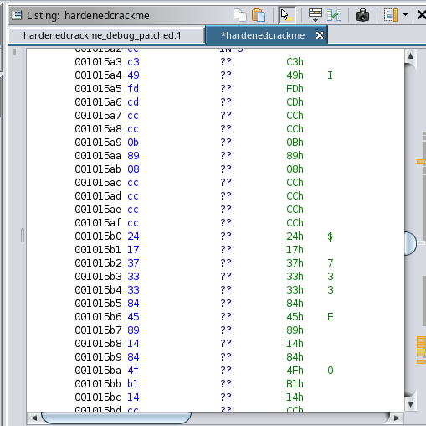
Encrypted data in the disassembly of hardenedcrackme.
- Since we know the constant that was used to encrypt these memory addresses, we can write a script that loops through this address range and XORs the value at each address with 0xcc to unencrypt the data. We will do this with Ghidra’s Python scripter Jython.
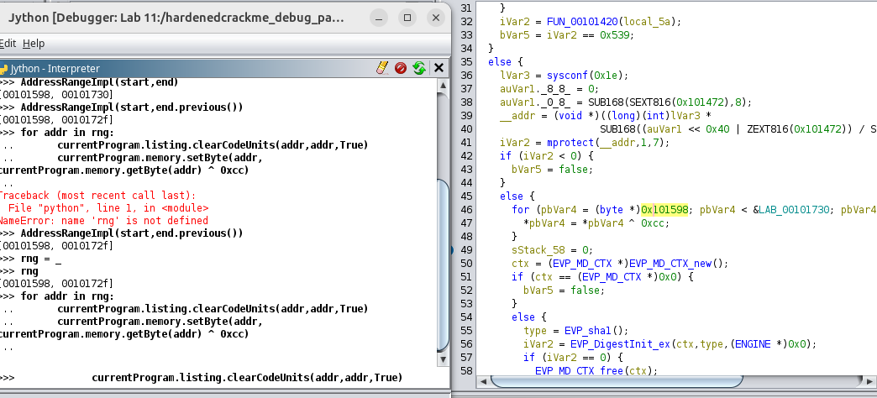
Using Jython in Ghidra to unencrypt the data in hardenedcrackme.

- Now, the data at these memory addresses can be disassembled in the listing and properly reflected in the decompilation:

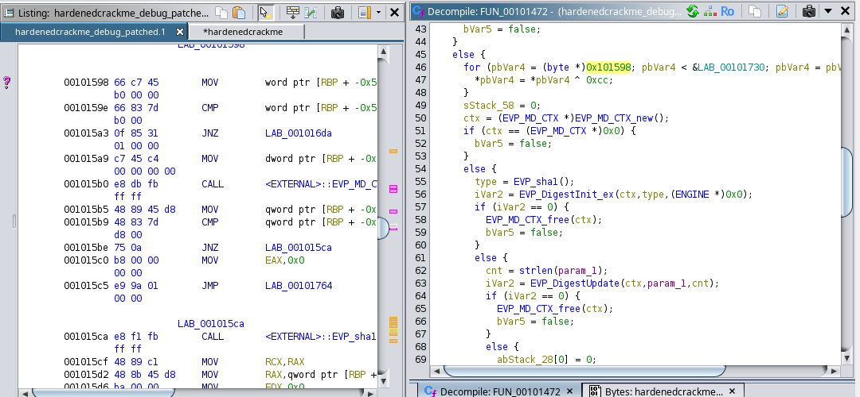
Unencrypted disassembly and restored decompilation from hardenedcrackme.
11. With the memory at these addresses unencrypted, we can now examine the rest of this function. We can now see that:
- Calls to OpenSSL’s EVP hashing library are made to generate a SHA1 hash
- A for-loop iteratively updates a value, multiplies it by 0x1f, and adds the value of a number stored in the index of a buffer that seemingly holds hashing data.
- Another for-loop that iteratively takes a value, multiplies it by 7, and then adds the value of a number stored in the index of the key buffer that we passed in.
- The values computed in the previous for-loops are then compared and the result of the comparison is returned.
- It is now clear that the operations in this hash-checking function perform the algorithm we have been looking for. We can now go and encode this algorithm into our own source file.

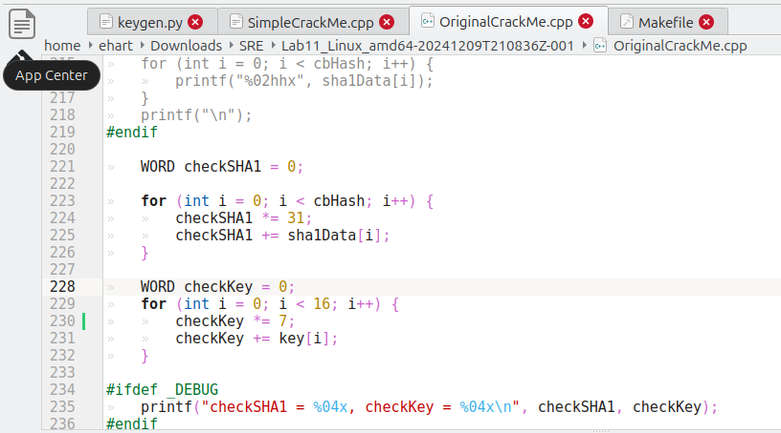
Source file with the extrapolated hashing algorithm from hardenedcrackme.
- Finally, we compile this new source file into an executable titled “newcrackme” and run it against the pre-existing correct credentials we were provided. To further prove accuracy, we run incorrect credentials against this program to verify that incorrect credentials don’t work.
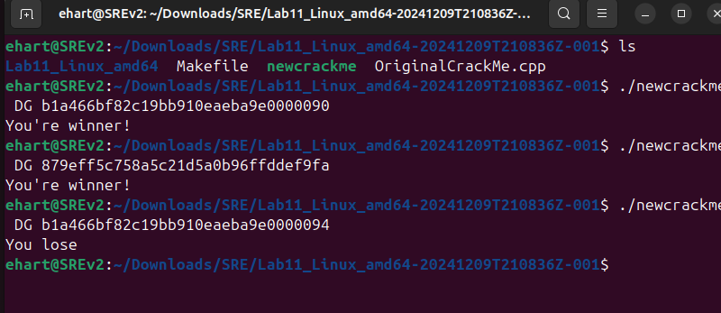
Successful usage of newcrackme.

Conclusion
In this lab, we were able to decipher protections applied to a key generator file to protect it from static and dynamic analysis. To defeat dynamic analysis, we patched the executable so that the resulting code from a call to ptrace() wouldn’t ever execute, which allowed us to debug the file. Through keen analysis of function operations and disassembly instructions, we were able to overcome symbol stripping and code encryption to follow the function’s call stack and extract the sensitive key-checking algorithm. We then implemented this algorithm into our source file, which was able to completely mimic the original executable.

